**SE1748 – SE161229 – Đỗ Thế Phi – Lab 1 SQL**

**Create Table :**

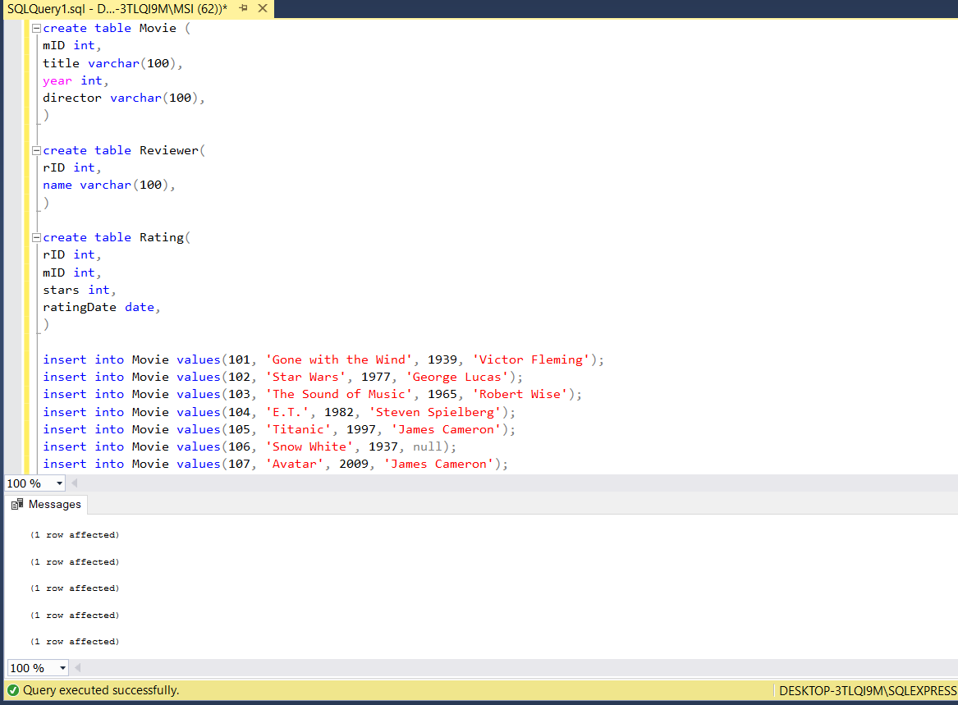

**Query 1 :**

**Query 2 :**

**Query 3 :**

**Query 4 :**

**Query 5 :**

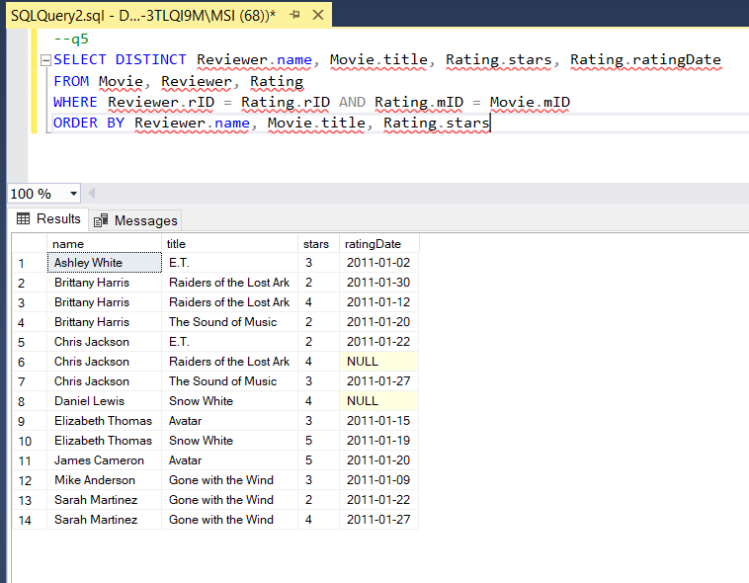

**Query 6 :**

**Query 7 :**

**Query 8 :**

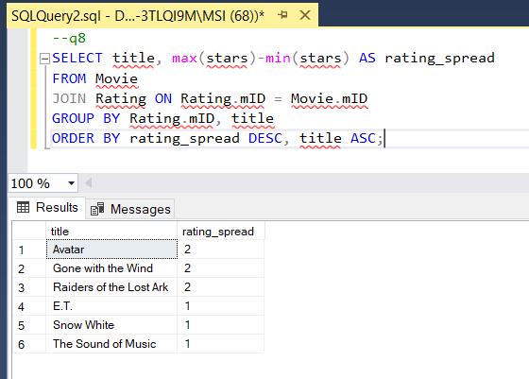

**Query 9 :**

**Query 10 :**

**Query 11 :**

**Query 12 :**

**Query 13 :**

**Query 14 :**

**Query 15 :**

**Query 16 :**

**Query 17 :**

**Query 18 :**

**Query 19 :**

**Query 20 :**

**Query 21 :**

**Query 22 :**

**Query 23 :**

**Query 24 :**

**Query 25 :**

